Lesson 6 – Teams and SAP



Exercise 15: Approve a Purchase Order from Teams 2

Exercise 15: Approve a Purchase Order from Teams
We are now going to copy the Purchase Order app to send an approval through Teams when created. We will then create a new Purchase Order and use Teams for approval.

- In the SAP Procurement solution, click on the Apps filter:
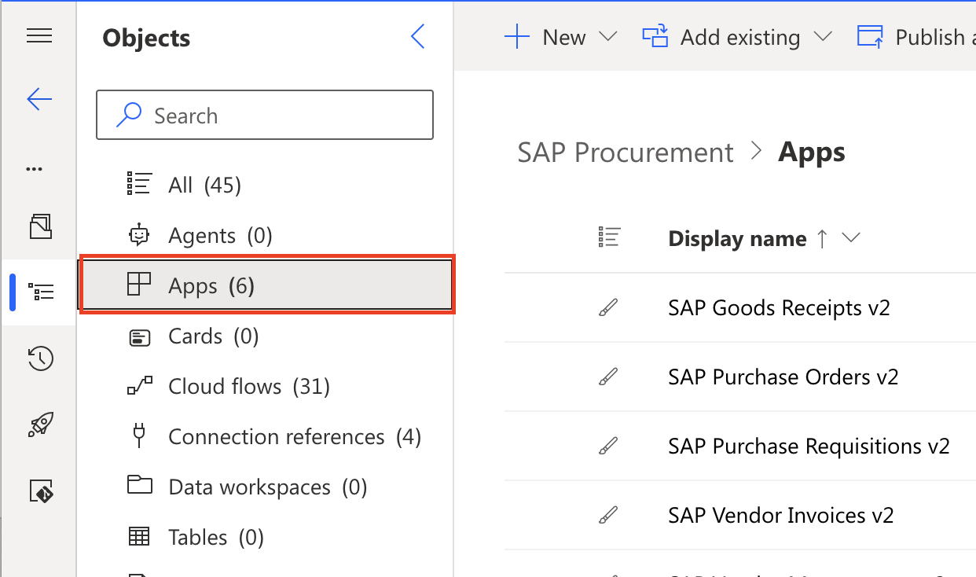

- Open the SAP Purchase Orders v2 app by clicking on the ellipsis and selecting Edit in new tab:
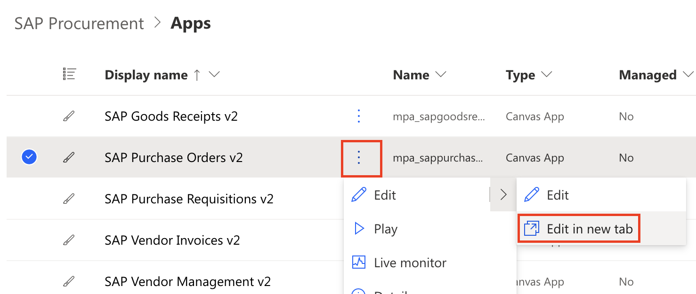

- In the upper right screen of the Power Apps editor, click the down arrow next to the Save icon and select Save As:
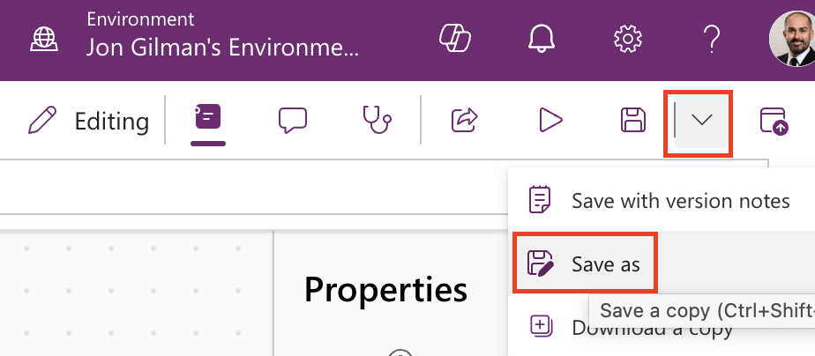

- Enter a new app name called SAP Purchase Orders With Teams Approval and click Save:
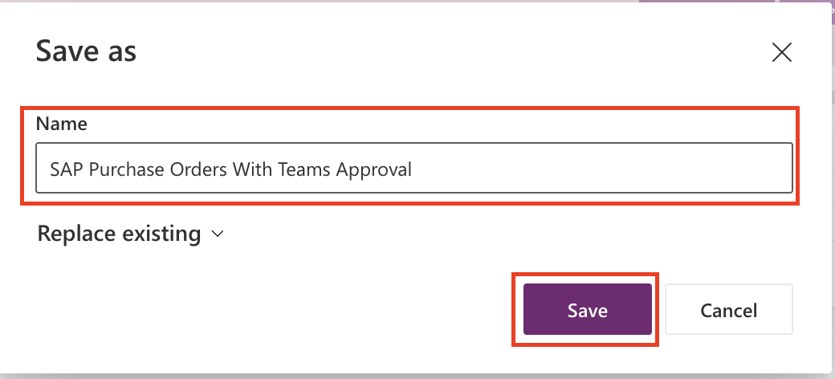

- On the left side menu, click on the Power Automate icon and then click the Add Flow button:
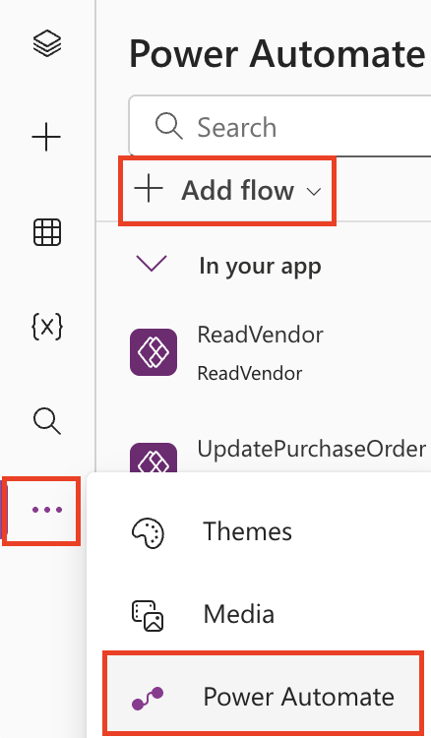

- Add the cloud flow to the app called CreatePurchaseOrderWithTeamsApproval:
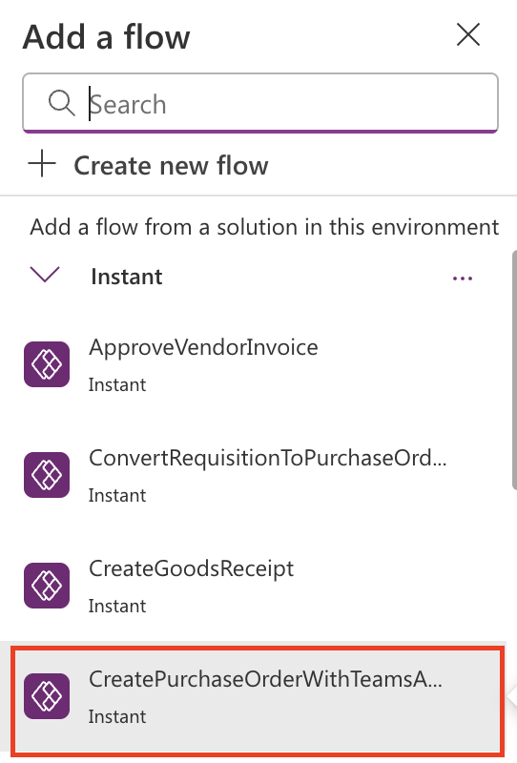

- Modify the Save Button to use the new cloud flow. In the Tree View, search for btnSave and then click on btnSaveEdit_Details.

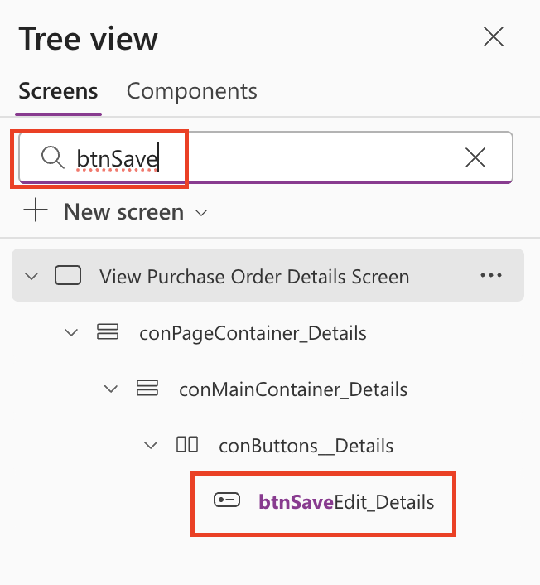

- Expand the OnSelect formula bar.

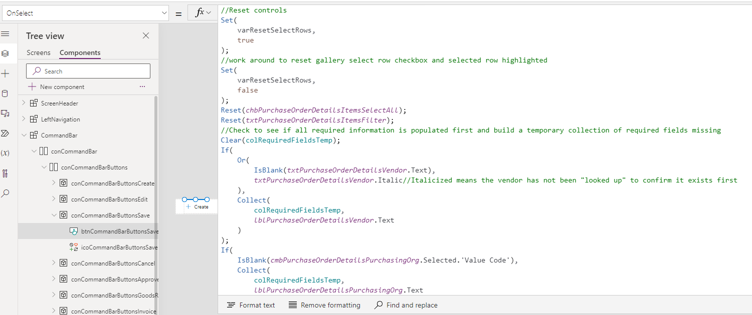

- Scroll down to where we are calling the Power Automate flow and replace CreatePurchaseOrder.Run with CreatePurchaseOrderWithTeamsApproval.Run. Now when we click on the Save button in the Purchase Order app, we will send an Approval through Teams.

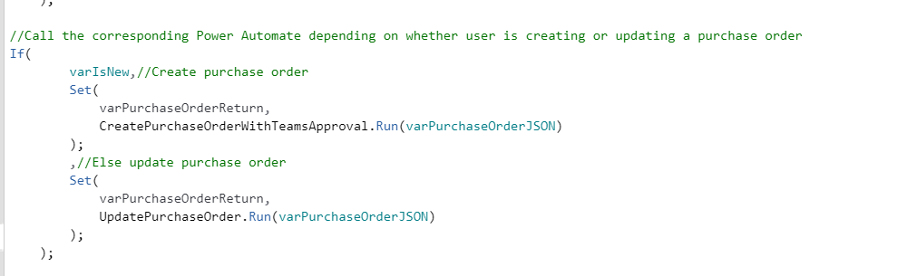

- Save the App. In the Tree View, click on Screens then click on Save Icon.

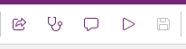
- Publish the App. Click the Publish App Icon.

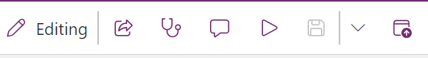

- Click the Play button the launch the new app:
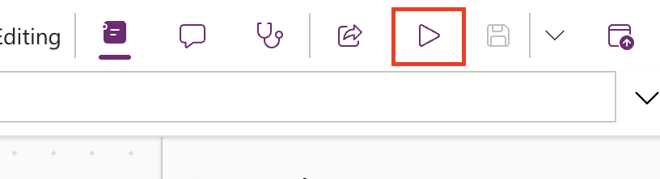

- In the new app, click the New Purchase Order button:
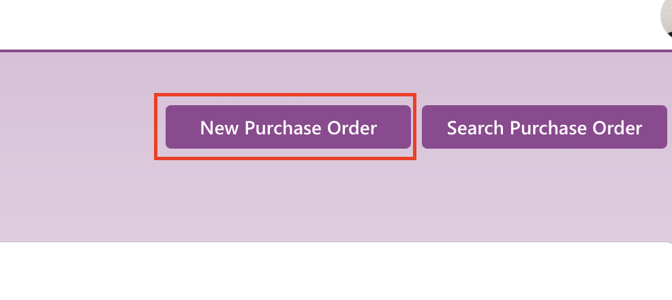

- Create the purchase order with the following information and then click on Save.

Vendor – 3000 Contoso Pharmaceuticals
Purchasing Organization – 3000 Best Run USA
Purchasing Group – 300 PG US
Location – 3000 – New York Plant
Currency – United States Dollars

Line Items

Material | Description | Qty | Unit Price
938 | Laser Printer | 1 | $250.00
938 | Printer Paper | 10 | $ 10.00
938 | Printer Toner | 1 | $ 100.00

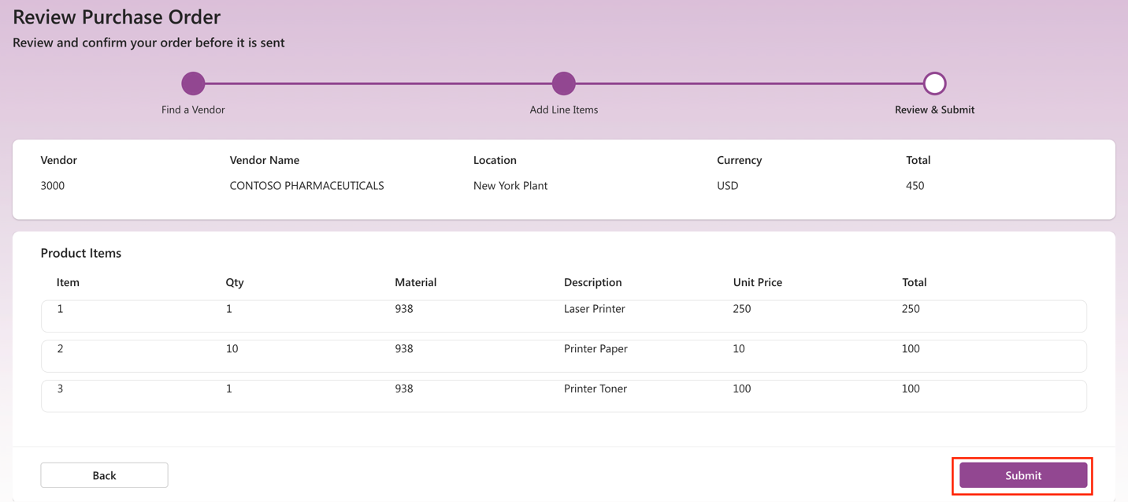

- Check for our Approval in Teams. Browse to www.office.com using your lab credentials and click on Teams.
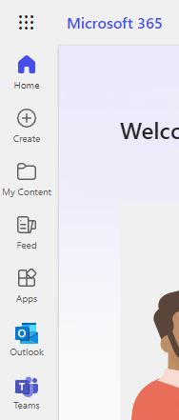

- Open the Approvals app. Click on the ellipse …. and select the Approvals app.

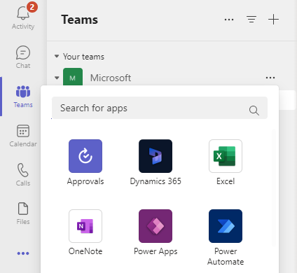

- In the upper right corner, select your lab environment.

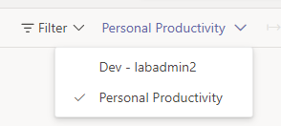

- Select the latest Approval Request for the PO you just created.

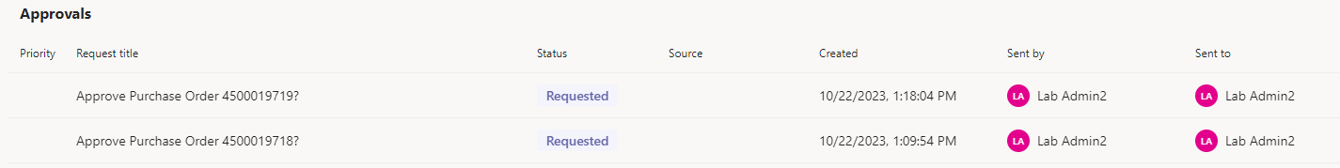

- You will see the list of all the items on the PO with the ability to click on the link and access the PO in the Purchase Order app. Click on Approve to approve the PO.

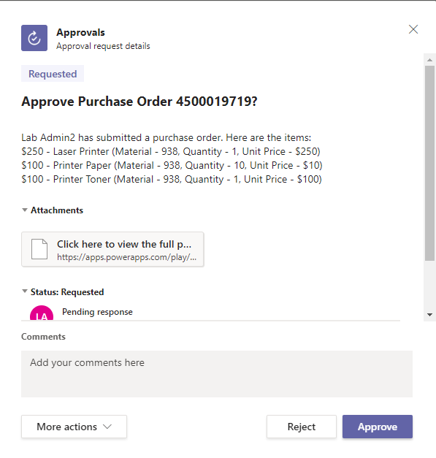
- Click back over to the tab with the Purchase Order app. Click on the Refresh button in the app and you will see that the Approval button is gone, our Approved By field is populated and the New Goods Receipt and New Invoice buttons are now available.

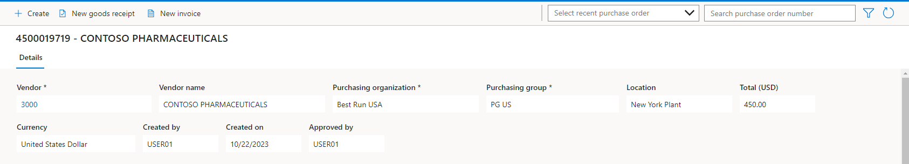

- Create a new Goods Receipt. Click on the New Goods Receipt.

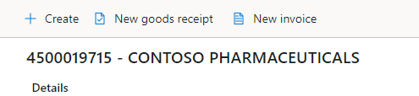
- Edit all 3 line items and select Warehouse 0001 for the Storage Location and then Save.

